**Course Methods test 3 Year 12**

Student name: ________________ Teacher name: ________________

**Task type: Response**

**Time allowed for this task: ___40________ mins**

**Number of questions: ____8_______**

**Materials required:** Calculator with CAS capability (to be provided by the student)

Standard items: Pens (blue/black preferred), pencils (including coloured), sharpener, correction fluid/tape, eraser, ruler, highlighters

Special items: Drawing instruments, templates, notes on one unfolded sheet of   
A4 paper, and up to three calculators approved for use in the WACE examinations

**Marks available: ___46___ marks**

**Task weighting: _10___%**

**Formula sheet provided: Yes**

**Note: All part questions worth more than 2 marks require working to obtain full marks.**

Q1 (3 marks) (3.3.4, 3.3.8)

The expected value of the discrete probability distribution given below is 2.8. Determine the values of  and hence determine Var(), the variance of .

|  |  |  |  |  |  |
| --- | --- | --- | --- | --- | --- |
|  | 1 | 2 | 3 | 4 | 5 |
| P() | 0.1 |  | 0.2 |  | 0.1 |

Q2 (10 marks) (3.3.6, 3.3.8)

A students wishes to play a gambling game on mufti day involving throwing two regular fair dice, each numbered 1 to 6. To play the game the student must pay $2 for each throw of two dice. If they score a double i.e two 1s, two 2s etc they win $6. If they throw a total of 7 they win $11 and anything else they receive nothing.

Let $ equal the profit a player receives on a single play.

1. Describe the random variable . (1 mark)
2. Complete the following table for . (3 marks)

|  |  |  |  |
| --- | --- | --- | --- |
|  |  |  |  |
| P() |  |  |  |

1. Determine the expected profit by a player on a single game. (3 marks)
2. Determine the standard deviation of . (3 marks)

Q3 (7 marks) (3.3.1, 3.3.8)

A factory produces toy cars. The probability that any toy car being defective is 0.15 and this is independent of any other car. If 20 toy cars are selected at random, let  equal the number of defective cars out of 20.

1. Describe the distribution . ( 2 marks)
2. Determine that probability that exactly 4 cars will be defective. (2 marks)
3. Determine the probability that at least 4 cars will be defective given that we know at least 2 cars are defective. (3 marks)

Q4 (4 marks) (4.1.3, 4.1.4)

Sound loudness,  dB, is measured by comparing the intensity of the sound, , with the intensity of a sound that is just detectable by the human ear, .

.

1. If the noise loudness in a room was 65 dB, express the intensity of sound in this room in terms of . ( 1 mark)
2. How many times is the intensity of a 105 dB noise level that of the intensity of a 35 dB noise level? (3 marks)

Q5 (5 marks) (4.1.6)

Below is a graph of  where  is a positive constant.

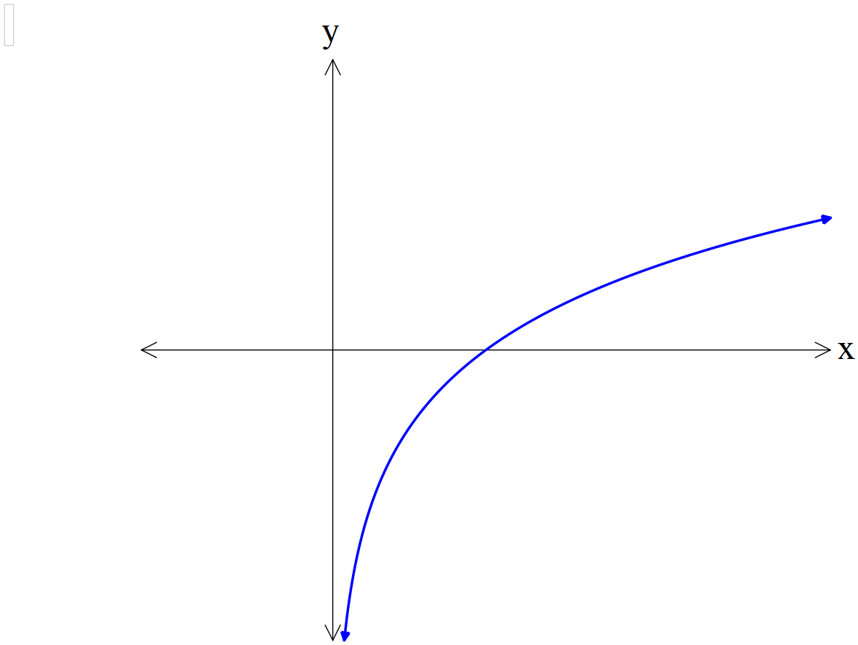

1. Sketch on the axes above  labelling major features. (2 marks)
2. Determine the values of ,() given that  contains points  and has a vertical asymptote at . ( 3 marks)

Q6 (6 marks) (4.1.11, 4.1.12)

1. Determine . (simplify) (3 marks)
2. Using your result in a) above and **NOT using your classpad** determine

. Show all working. (3 marks)

Q7 (6 marks) (4.2.2)

Consider the continuous random variable  and its probability density function shown below.

|  |  |
| --- | --- |
|  | 1. Determine the exact value of .   (2 marks)   1. Determine Prob to four decimal places.   (4 marks) |

Q8 (5 marks) (4.2.2)

Consider a continuous random variable, , that has the following probability density function.

 with  being constants.

1. Determine the cumulative distribution function, **,** in terms of .

(2 marks)

1. Given that  solve for approximate values of to two decimal places.

(3 marks)

**Extra working space**